Project Design Phase II
Data Flow Diagram & User Stories

Date | 18 Feb 2026
Team ID | LTVIP2026TMIDS74685
Project Name | Visualizing Housing Market Trends: An Analysis of Sale Prices and Features using Tableau.
Maximum Marks | 4 Marks

Data Flow Diagrams:
A Data Flow Diagram (DFD) is a traditional visual representation of the information flows within a system. A neat and clear DFD can depict the right amount of the system requirement graphically. It shows how data enters and leaves the system, what changes the information, and where data is stored.

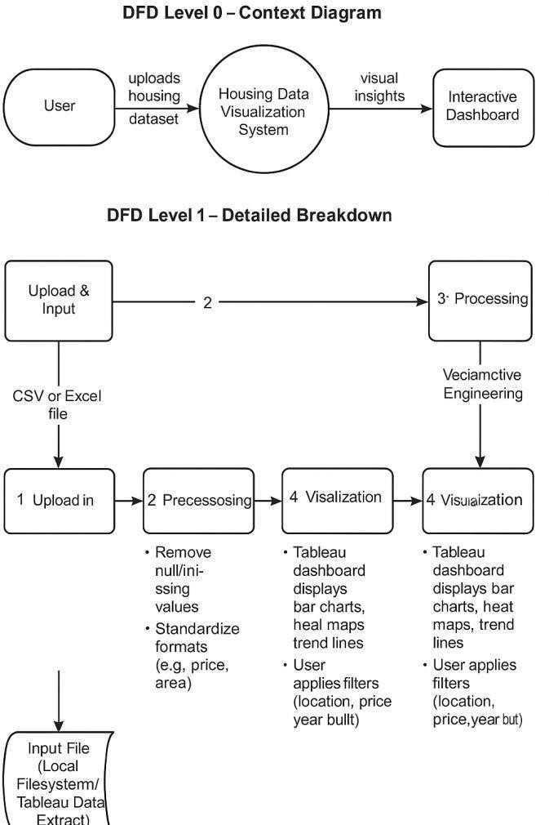

DFD Level 0 - Project Overview

- User uploads the housing dataset (CSV/Excel)
- Preprocessing Module (Python) cleans and transforms the data
- Feature Engineering Module adds derived attributes (e.g., price/sq. ft)
- Visualization Layer (Tableau Dashboard) displays trends and insights
- User views or exports filtered insights

DFD Level 1 - Detailed Process
- Data Upload → File Validation → Missing Value Handling
- Data Transformation → Unit Normalization → Column Derivations
- Dashboard → Filters by Region, Price, Bedrooms, etc. → Displays Graphs and Charts

User Stories

Use the below template to list all the user stories for the product.

User Type | Functional  Requirement (Epic) | User Story  Number | User Story / Task | Acceptance criteria | Priority / Release
Data  Analyst /  Student | Data Upload | USN-1 | As a user, I can upload a housing dataset in  CSV/Excel format | Dataset successfully uploaded and ready for processing | High / Sprint-1
Data  Analyst /  Student | Data  Preprocessing | USN-2 | As a user, I can clean data and remove missing entries | Data cleaned with no missing/null values | High / Sprint-1
Data  Analyst /  Student | Feature  Engineering | USN-3 | As a user, I can create new metrics like price per sqft, age of house | Derived fields are generated correctly | High / Sprint-1
End User / Viewer | Visualization Filtering | USN-4 | As a user, I can filter housing data  by location, price, or bedroom count | Filters apply correctly on dashboard | High / Sprint-2
End User / Viewer | Trend Analysis | USN-5 | As a user, I can view charts showing sale price trends over time | Charts show monthly/yearly price trends | High / Sprint-2
End User / Viewer | Export Data | USN-6 | As a user, I can export filtered visualizations as images or PDFs | Export works and saves in selected format | Medium /  Sprint-3

